food guide pyramid | Carbohydrates are any of various compounds of carbon, hydrogen, and oxygen (as sugars, starches, or celluloses) most of which are formed by plants and are a major animal food.  Most people think of bread when they think of carbohydrates.
carbohydrate | Dehydration is the loss of water or body fluids.
dehydration | Fats are any of numerous compounds of carbon, hydrogen, and oxygen that make up most of plant and animal fat, are a major class of energy-rich food, and can be dissolved by ether but not by water. "Bad" fat is  saturated fat.
fat | Fiber is a mostly indigestible material in food that stimulates the intestine to move its contents along. Fruits, vegetables and whole grains are excellent sources of fiber. You should eat 2.5 cups of vegetables every day and 1.5 cups of fruit.
fiber | Junk food is classified as foods or drinks that are high in calories but low in nutritional value.
junk food | All grains start out as whole grains. If, after milling, they keep all three parts of the original grain – the germ, bran and endosperm - then they are still considered whole grains.
whole grains | Physical activity is any activity that causes your body to work harder than normal.
physical activity | The food guide pyramid suggests optimal nutrition guidelines for each food category, per day, using a graphic of a pyramid with dividing lines, to represent suggested percentages of the daily diet for each food group.
active lifestyle | (United States Department of Agriculture)  The U.S.D.A. organization develops the Food Guide Pyramid.
U.S.D.A. | An active lifestyle is a lifestyle that includes regular exercise for 30 minutes or more, 5 times a week or more.
Check Yourself:  A Guide to Health  created by  Natalie Cates  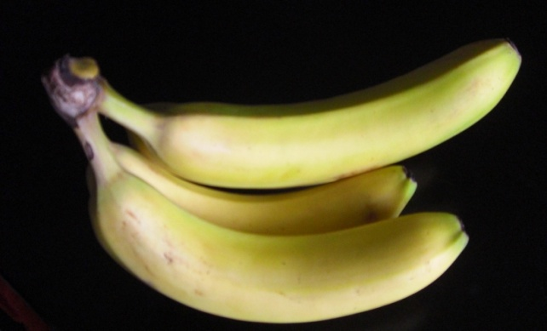 | Directions:  (Similar to Go Fish!)  Divide into two teams. Each team will be dealt half the cards in no particular order. The teams will look at their cards together & pull out any matching words & definitions. If you have a definition, you will think of the word and ask the other team if they have it. If you have a word, you think of the definition and again ask the other team. If you came up with the correct word or definition, they should have it and you get a point. After each turn, the other team goes.  After all cards are gone, the team with the most points wins.

