Name:______________ Date: ______________

Eat Smart and Play Hard!
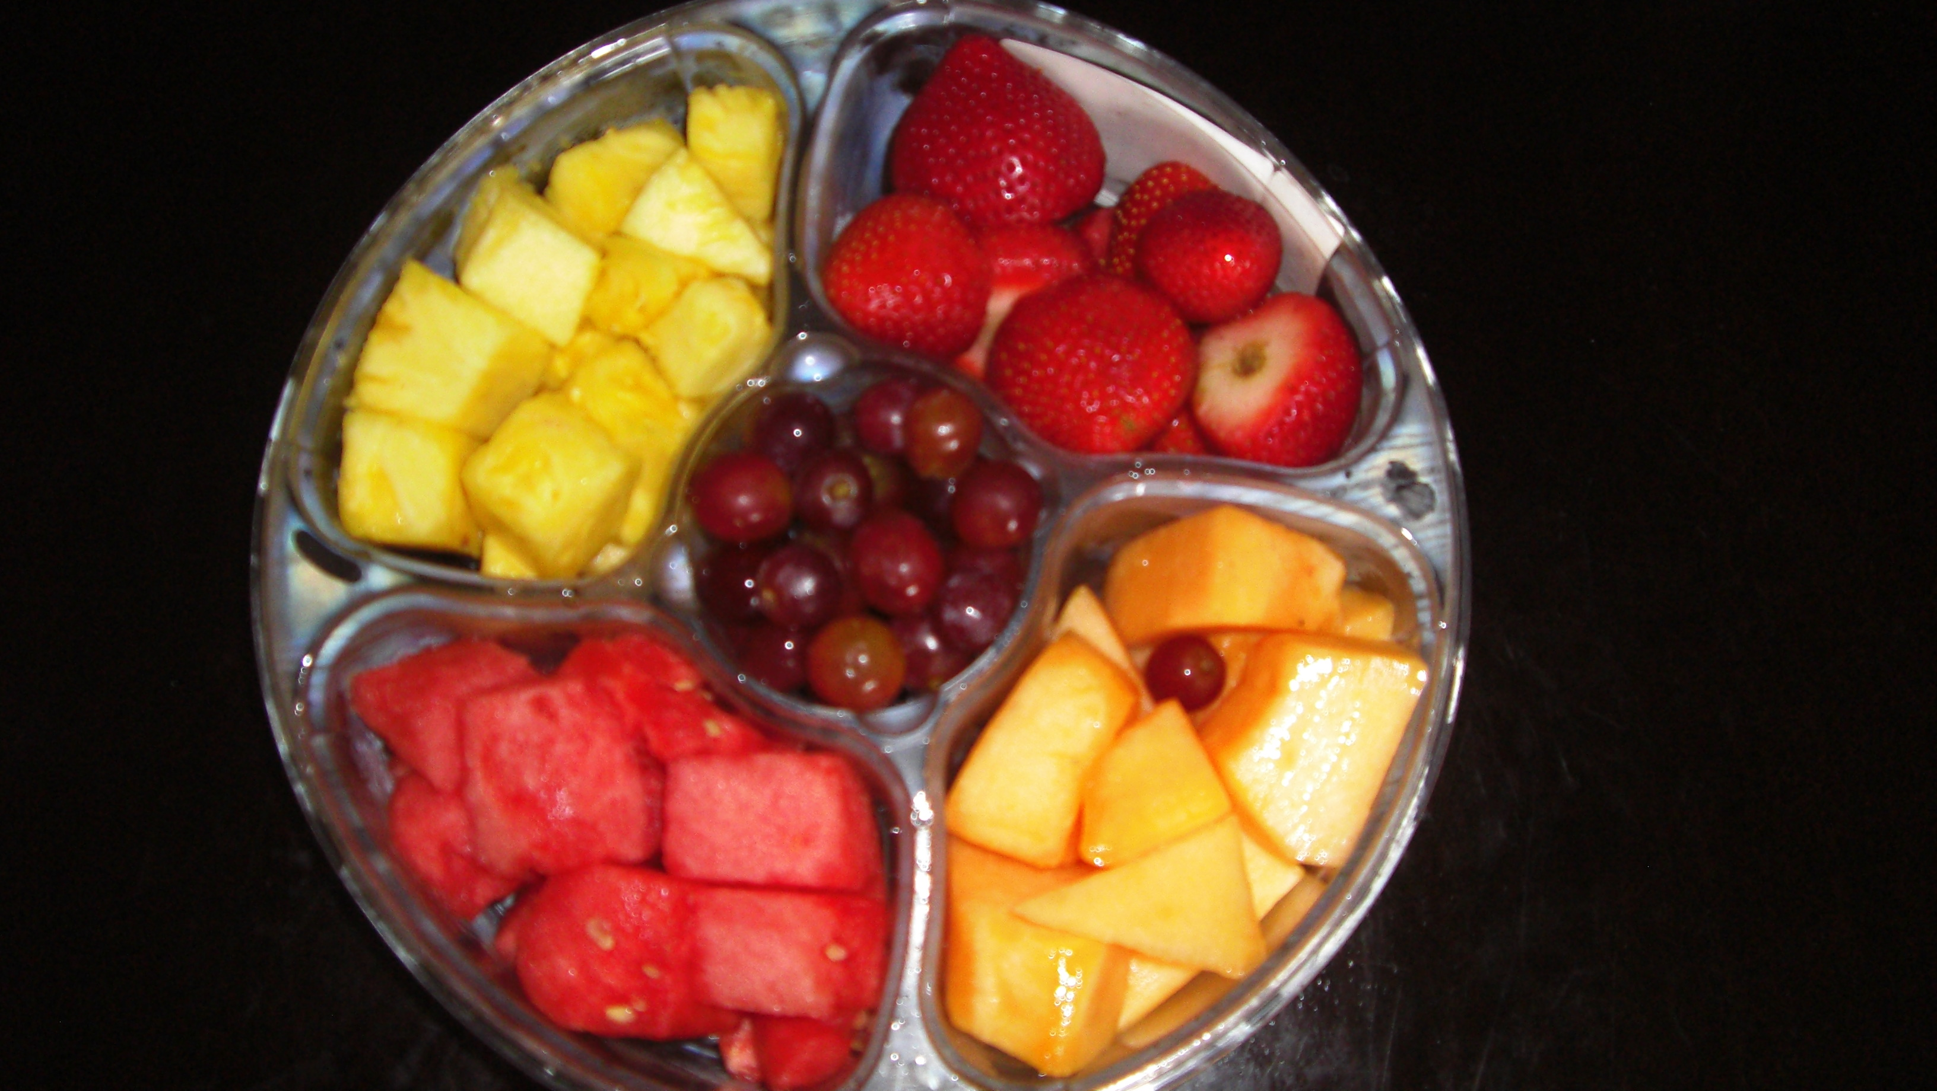
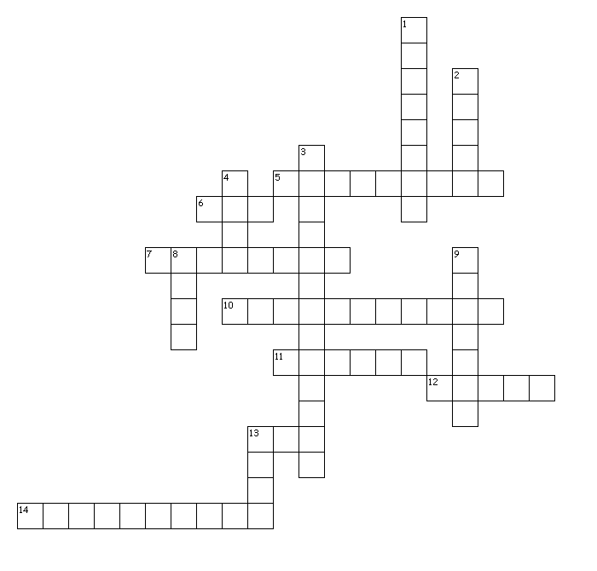

Directions: Use the clues written below to fill in the appropriate blocks on the puzzle. Make sure you spell correctly! If you do not know one, go on to the next. There is no certain order you need to follow. Have fun!

__________________________________________________________________________________________

Across Down
5. bad fat 1. type of activity that makes your body work harder than
6. number of groups in food pyramid normal
7. high calories, fats, sugars, low nutritional value 2. half your daily grains should be _____
10. the loss of water or body fluids 3. breads and pastas
11. 1.5 cups per day 4. drink three glasses a day
12. aids in digestion 8. designed the food pyramid
13. hours of recommended exercise per day 9. meats, beans, and fish
14. 2.5 cups per day 13. smallest group in food pyramid

