N | U | T | S | O
2.5 cups | dehydration | 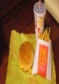 | fats and oils | junk food
physical  activity | milk | fiber | 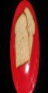 | meats and beans
saturated | 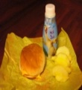 | FREE  SPACE | healthy  lifestyle | 1.5 cups
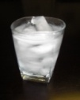 | rest | eight | carbohydrates | protein
U.S.D.A. |  | one hour | 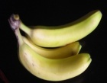 | six
Directions: Listen carefully to the letter and definition I call out. See if you have the matching word or picture. If you do, place one of your tokens on that square. Once you have five squares covered in a row (either horizontally, vertically, or diagonally), yell out NUTSO!

NUTSO Call Out
1. What is the loss of water or body fluids called?
2. Half of your daily grains should be _______ grains.
3. These people design the food guide pyramid.
4. Breads and pastas are examples of ____________.
5. This is the best way to keep your body hydrated.
6. This helps your digestive track work properly.
7. This fat is considered “bad” fat.
8. How many groups are in the food pyramid?
9. This is any activity that makes your body work harder than normal.
10. These foods have high calories, sugars & fats, but little nutritional value.
11. How many vegetables should you eat every day?
12. How much fruit should you eat every day?
13. How much physical activity should you get each day?
14. Besides healthy eating and exercise, what else is very important to your health?
15. This meal is a bad choice!
16. This meal is a healthier choice!
17. You should consume five ounces of ________ every day.
18. This is the smallest group in the food pyramid.
19. You should get 3 cups of ____ each day growing up.
20. A balanced diet and regular exercise are key components of _____.
21. This food is part of the fruit food group.
22. This is considered a junk food.
23. About how many hours should you sleep each night?
24. Meats and beans are a source of ________.
25. FREE SPACE

